Veg h 🡪 Soil T

lm(formula = meanT ~ veg_h_mean * pop, data = data4)

Estimate Std. Error t value Pr(>|t|)

(Intercept) 18.378708 0.310201 59.248 < 2e-16 ***

veg_h_mean -0.049860 0.008536 -5.841 1.40e-08 ***

popR -1.760718 0.421004 -4.182 3.83e-05 ***

popT -0.125164 0.383500 -0.326 0.7444

veg_h_mean:popR 0.026743 0.012461 2.146 0.0327 *

veg_h_mean:popT 0.025606 0.013077 1.958 0.0512 .

lm(formula = t_meanT ~ t_veg_h_mean + t_veg_h_mean:pop, data = data4)

Estimate Std. Error t value Pr(>|t|)

(Intercept) 8.483e-16 5.475e-02 0.000 1.000

t_veg_h_mean -4.227e-01 9.499e-02 -4.450 1.22e-05 ***

t_veg_h_mean:popR 1.447e-01 1.365e-01 1.060 0.290

t_veg_h_mean:popT 1.088e-01 1.330e-01 0.818 0.414



Soil T + Veg h 🡪 Phen

> model1<-lm(phen_index_avg~(meanT+veg_h_mean)*pop,data=data4,na.action="na.fail")

> models1<-dredge(model1)

> summary(model.avg(models1, subset = delta < 2))

Model-averaged coefficients:

(full average)

Estimate Std. Error Adjusted SE z value Pr(>|z|)

(Intercept) -0.888926 1.277267 1.281605 0.694 0.48793

meanT 0.185924 0.067715 0.067963 2.736 0.00623 **

popR 2.771583 2.588424 2.593236 1.069 0.28517

popT -0.162750 2.176022 2.184301 0.075 0.94061

veg_h_mean 0.013536 0.007954 0.007976 1.697 0.08969 .

meanT:popR -0.194960 0.144394 0.144701 1.347 0.17787

meanT:popT 0.076425 0.121772 0.122233 0.625 0.53181

popR:veg_h_mean 0.010053 0.013244 0.013263 0.758 0.44848

popT:veg_h_mean 0.002524 0.008508 0.008540 0.296 0.76754

Relative variable importance:

meanT pop veg_h_mean meanT:pop pop:veg_h_mean

Importance: 1.00 1.00 1.00 0.80 0.47

N containing models: 3 3 3 2 2



> model1<-lm(t_phen_index_avg~t_meanT+t_veg_h_mean+t_meanT:population+t_veg_h_mean:population,data=data4,na.action="na.fail")

> models1<-dredge(model1)

> summary(model.avg(models1, subset = delta < 4))

Model-averaged coefficients:

(full average)

Estimate Std. Error Adjusted SE z value Pr(>|z|)

(Intercept) -2.704e-16 5.572e-02 5.595e-02 0.000 1.00000

t_meanT 3.325e-01 1.020e-01 1.024e-01 3.247 0.00116 **

t_veg_h_mean 2.070e-01 7.683e-02 7.710e-02 2.685 0.00726 **

populationRemmene:t_meanT -3.670e-01 1.423e-01 1.429e-01 2.569 0.01020 *

populationTånga Hed:t_meanT 3.209e-03 1.382e-01 1.388e-01 0.023 0.98156

populationRemmene:t_veg_h_mean 2.482e-02 8.238e-02 8.257e-02 0.301 0.76374

populationTånga Hed:t_veg_h_mean 1.736e-02 7.145e-02 7.166e-02 0.242 0.80856

Relative variable importance:

t_meanT t_veg_h_mean population:t_meanT population:t_veg_h_mean

Importance: 1.00 1.00 1.00 0.17

N containing models: 2 2 2 1

Soil T + Veg h 🡪 Ants

> model1<-glm.nb(n_redants~(veg_h_mean*meanT)*population,na.action="na.fail",data=data4)

> models1<-dredge(model1)

> summary(model.avg(models1, subset = delta < 2))

Model-averaged coefficients:

(full average)

Estimate Std. Error Adjusted SE z value Pr(>|z|)

(Intercept) 14.9018323 4.9163765 4.9322606 3.021 0.00252 **

meanT -0.8704770 0.2981636 0.2990579 2.911 0.00361 **

populationRemmene -0.9783712 0.6411066 0.6438154 1.520 0.12860

populationTånga Hed 2.5258251 0.9379964 0.9395176 2.688 0.00718 **

veg_h_mean -0.2862303 0.1516348 0.1521094 1.882 0.05987 .

meanT:veg_h_mean 0.0190400 0.0093333 0.0093607 2.034 0.04195 *

populationRemmene:veg_h_mean 0.0006386 0.0177219 0.0177969 0.036 0.97138

populationTånga Hed:veg_h_mean -0.0356213 0.0329123 0.0329575 1.081 0.27978

Relative variable importance:

meanT population veg_h_mean meanT:veg_h_mean population:veg_h_mean

Importance: 1.00 1.00 1.00 1.00 0.63

N containing models: 2 2 2 2 1

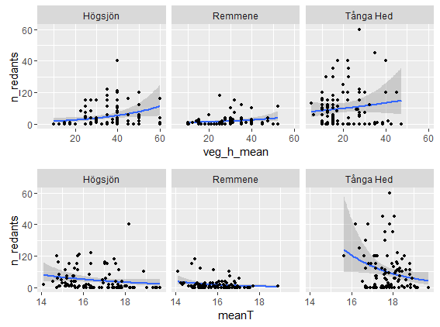

SEMs

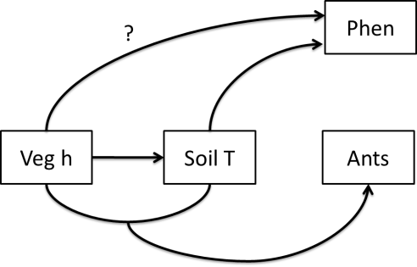

#1 Effects of temperature and vegetation height on phenology

> sem1<-list(

+ glm.nb(n_redants~meanT+veg_h_mean+meanT:veg_h_mean+pop,data=data4),

+ glm(meanT~veg_h_mean+pop,family="gaussian",data=data4),

+ lm(phen_index_avg~meanT+veg_h_mean+pop,data=data4)

+ )

> sem.fit(sem1,data4,corr.errors=c("meanT:veg_h_mean~~meanT",

+ "meanT:veg_h_mean~~veg_h_mean"))#p=0.914

> sem.coefs(sem1,data4)

response predictor estimate std.error p.value

1 n_redants popT 1.55577518 0.260890649 0.0000 ***

2 n_redants popR -1.01500781 0.253402184 0.0001 ***

3 n_redants meanT -0.65884997 0.224897387 0.0034 **

4 n_redants meanT:veg_h_mean 0.01225816 0.006890743 0.0753

5 n_redants veg_h_mean -0.18449840 0.116538153 0.1134

6 meanT veg_h_mean -0.03361932 0.005301636 0.0000 ***

7 meanT popR -0.89034263 0.140924738 0.0000 ***

8 meanT popT 0.63020020 0.153493665 0.0001 ***

9 phen_index_avg popT 1.33595698 0.135673190 0.0000 ***

10 phen_index_avg veg_h_mean 0.01760309 0.004860627 0.0003 ***

11 phen_index_avg meanT 0.15546696 0.050376638 0.0022 **

12 phen_index_avg popR -0.04086872 0.129144187 0.7519

#2 Only effect of temperature on phenology

> sem1<-list(

+ glm.nb(n_redants~meanT+veg_h_mean+meanT:veg_h_mean+pop,data=data4),

+ glm(meanT~veg_h_mean+pop,family="gaussian",data=data4),

+ glm(phen_index_avg~meanT+pop,family="gaussian",data=data4)

+ )

> sem.fit(sem1,data4,corr.errors=c("meanT:veg_h_mean~~meanT",

+ "phen_index~~veg_h_mean","meanT:veg_h_mean~~veg_h_mean"))#p=0.729

> sem.coefs(sem1,data4) #Mean T not signif

response predictor estimate std.error p.value

1 n_redants popT 1.55577518 0.260890649 0.0000 ***

2 n_redants popR -1.01500781 0.253402184 0.0001 ***

3 n_redants meanT -0.65884997 0.224897387 0.0034 **

4 n_redants meanT:veg_h_mean 0.01225816 0.006890743 0.0753

5 n_redants veg_h_mean -0.18449840 0.116538153 0.1134

6 meanT veg_h_mean -0.03361932 0.005301636 0.0000 ***

7 meanT popR -0.89034263 0.140924738 0.0000 ***

8 meanT popT 0.63020020 0.153493665 0.0001 ***

9 phen_index_avg popT 1.16155570 0.129452753 0.0000 ***

10 phen_index_avg meanT 0.09189705 0.048192589 0.0575

11 phen_index_avg popR -0.17722121 0.126079600 0.1609

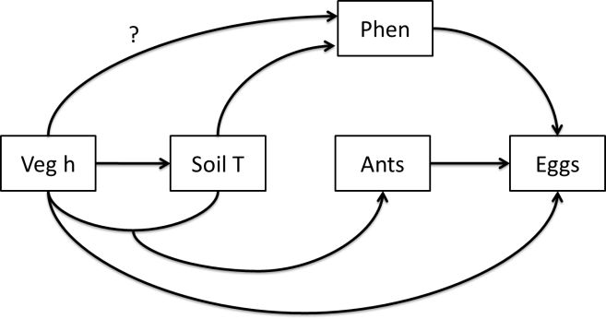

> sem1<-list(

+ glm.nb(n_eggs_max~phen_index_avg+veg_h_mean+n_redants+pop,data=data4),

+ glm.nb(n_redants~meanT+veg_h_mean+meanT:veg_h_mean+pop,data=data4),

+ glm(meanT~veg_h_mean+pop,family="gaussian",data=data4),

+ glm(phen_index_avg~meanT+pop,family="gaussian",data=data4)

+ )

> sem.fit(sem1,data4,corr.errors=c("meanT:veg_h_mean~~meanT",

+ "phen_index_avg~~veg_h_mean","meanT:veg_h_mean~~veg_h_mean"))#p=0.002

> sem.fit(sem1,data4,corr.errors=c("meanT:veg_h_mean~~meanT","phen_index_avg~~veg_h_mean",

+ "meanT:veg_h_mean~~veg_h_mean","meanT~~n_eggs_max"))#p=0.078

> sem.coefs(sem1,data4)

response predictor estimate std.error p.value

1 n_eggs_max phen_index_avg 0.341557491 0.110696663 0.0020 **

2 n_eggs_max popR 0.386952100 0.234253274 0.0986

3 n_eggs_max popT 0.344647308 0.307911467 0.2630

4 n_eggs_max n_redants 0.011006768 0.010584709 0.2984

5 n_eggs_max veg_h_mean 0.006671085 0.008858485 0.4514

6 n_redants popT 1.555775177 0.260890649 0.0000 ***

7 n_redants popR -1.015007812 0.253402184 0.0001 ***

8 n_redants meanT -0.658849975 0.224897387 0.0034 **

9 n_redants meanT:veg_h_mean 0.012258157 0.006890743 0.0753

10 n_redants veg_h_mean -0.184498401 0.116538153 0.1134

11 meanT veg_h_mean -0.033619317 0.005301636 0.0000 ***

12 meanT popR -0.890342626 0.140924738 0.0000 ***

13 meanT popT 0.630200200 0.153493665 0.0001 ***

14 phen_index_avg popT 1.161555701 0.129452753 0.0000 ***

15 phen_index_avg meanT 0.091897051 0.048192589 0.0575

16 phen_index_avg popR -0.177221214 0.126079600 0.1609

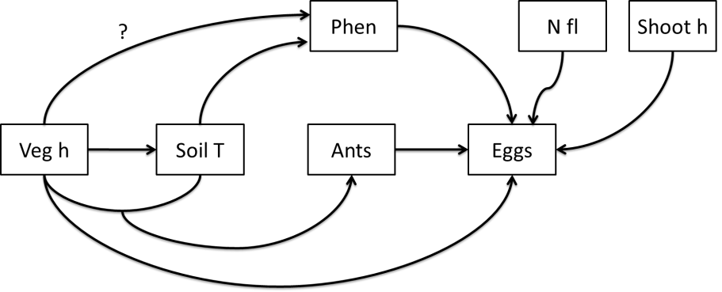

> sem1<-list(

+ glm.nb(n_eggs_max~phen_index_avg+shoot_h+n_fl+veg_h_mean+n_redants+pop,data=data4),

+ glm.nb(n_redants~meanT+veg_h_mean+meanT:veg_h_mean+pop,data=data4),

+ glm(meanT~veg_h_mean+pop,family="gaussian",data=data4),

+ glm(phen_index_avg~meanT+pop,family="gaussian",data=data4)

+ )

> sem.fit(sem1,data4,corr.errors=c("meanT:veg_h_mean~~meanT","n_eggs_max~~meanT",

+ "phen_index_avg~~shoot_h","phen_index_avg~~n_fl","shoot_h~~n_fl","phen_index_avg~~veg_h_mean","meanT:veg_h_mean~~veg_h_mean"))#p=0.0

> sem.fit(sem1,data4,corr.errors=c("meanT:veg_h_mean~~meanT","n_eggs_max~~meanT",

+ "phen_index_avg~~shoot_h","phen_index_avg~~n_fl","shoot_h~~n_fl","phen_index_avg~~veg_h_mean","meanT:veg_h_mean~~veg_h_mean","meanT~~shoot_h","n_redants~~shoot_h","n_redants~~n_fl","n_redants~~phen_index_avg"))#p=0.256

> sem.coefs(sem1,data4)

response predictor estimate std.error p.value

1 n_eggs_max n_fl 0.21127636 0.040289235 0.0000 ***

2 n_eggs_max popT -0.68232466 0.321206305 0.0336 *

3 n_eggs_max shoot_h 0.03335942 0.017201713 0.0525

4 n_eggs_max n_redants 0.01735095 0.009482739 0.0673

5 n_eggs_max veg_h_mean -0.01530534 0.009055337 0.0910

6 n_eggs_max phen_index_avg 0.11719177 0.102439736 0.2526

7 n_eggs_max popR 0.20477497 0.211841792 0.3337

8 n_redants popT 1.55577518 0.260890649 0.0000 ***

9 n_redants popR -1.01500781 0.253402184 0.0001 ***

10 n_redants meanT -0.65884997 0.224897387 0.0034 **

11 n_redants meanT:veg_h_mean 0.01225816 0.006890743 0.0753

12 n_redants veg_h_mean -0.18449840 0.116538153 0.1134

13 meanT veg_h_mean -0.03361932 0.005301636 0.0000 ***

14 meanT popR -0.89034263 0.140924738 0.0000 ***

15 meanT popT 0.63020020 0.153493665 0.0001 ***

16 phen_index_avg popT 1.16155570 0.129452753 0.0000 ***

17 phen_index_avg meanT 0.09189705 0.048192589 0.0575

18 phen_index_avg popR -0.17722121 0.126079600 0.1609

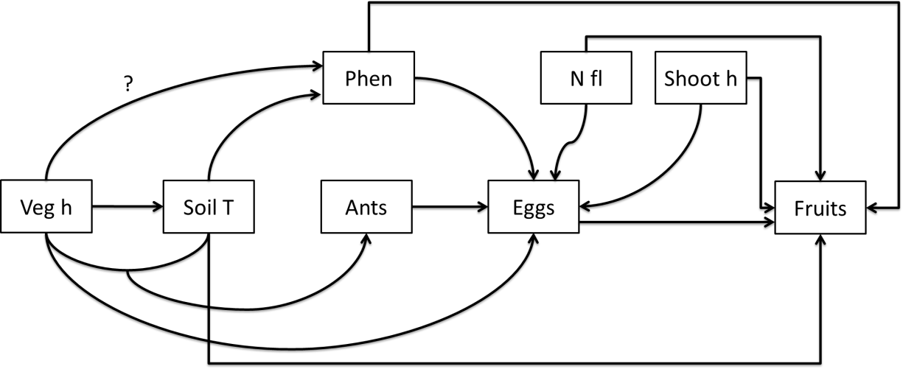

> sem1<-list(

+ glm(n_intact_fruits~phen_index_avg+n_fl+shoot_h+meanT+n_eggs_max+pop,family="poisson",data=data4),

+ glm.nb(n_eggs_max~phen_index_avg+n_fl+shoot_h+veg_h_mean+n_redants+pop,data=data4),

+ glm.nb(n_redants~meanT+veg_h_mean+meanT:veg_h_mean+pop,data=data4),

+ glm(meanT~veg_h_mean+pop,family="gaussian",data=data4),

+ glm(phen_index_avg~meanT+pop,family="gaussian",data=data4)

+ )

> sem.fit(sem1,data4,corr.errors=c("meanT:veg_h_mean~~meanT","n_eggs_max~~meanT",

"phen_index~~n_redants","phen_index_avg~~veg_h_mean","meanT:veg_h_mean~~veg_h_mean",

"phen_index_avg~~n_fl","shoot_h~~phen_index_avg","shoot_h~~n_fl"))#p=0

> sem.fit(sem1,data4,corr.errors=c("meanT:veg_h_mean~~meanT","n_eggs_max~~meanT",

"phen_index_avg~~n_redants","phen_index_avg~~veg_h_mean","meanT:veg_h_mean~~veg_h_mean","phen_index_avg~~n_fl","shoot_h~~phen_index_avg","shoot_h~~n_fl","meanT~~shoot_h","n_redants~~n_fl","n_redants~~shoot_h","n_redants~~n_intact_fruits"))#p=0.419

> sem.coefs(sem1,data4)

response predictor estimate std.error p.value

1 n_intact_fruits n_fl 0.12542610 0.017448105 0.0000 ***

2 n_intact_fruits n_eggs_max -0.05736465 0.008630376 0.0000 ***

3 n_intact_fruits phen_index_avg 0.47129635 0.101902453 0.0000 ***

4 n_intact_fruits popT 0.97640958 0.226784901 0.0000 ***

5 n_intact_fruits shoot_h 0.02394975 0.010715163 0.0254 *

6 n_intact_fruits popR -0.60833150 0.312202489 0.0514

7 n_intact_fruits meanT 0.10864027 0.077532350 0.1611

8 n_eggs_max n_fl 0.21127636 0.040289235 0.0000 ***

9 n_eggs_max popT -0.68232466 0.321206305 0.0336 *

10 n_eggs_max shoot_h 0.03335942 0.017201713 0.0525

11 n_eggs_max n_redants 0.01735095 0.009482739 0.0673

12 n_eggs_max veg_h_mean -0.01530534 0.009055337 0.0910

13 n_eggs_max phen_index_avg 0.11719177 0.102439736 0.2526

14 n_eggs_max popR 0.20477497 0.211841792 0.3337

15 n_redants popT 1.55577518 0.260890649 0.0000 ***

16 n_redants popR -1.01500781 0.253402184 0.0001 ***

17 n_redants meanT -0.65884997 0.224897387 0.0034 **

18 n_redants meanT:veg_h_mean 0.01225816 0.006890743 0.0753

19 n_redants veg_h_mean -0.18449840 0.116538153 0.1134

20 meanT veg_h_mean -0.03361932 0.005301636 0.0000 ***

21 meanT popR -0.89034263 0.140924738 0.0000 ***

22 meanT popT 0.63020020 0.153493665 0.0001 ***

23 phen_index_avg popT 1.16155570 0.129452753 0.0000 ***

24 phen_index_avg meanT 0.09189705 0.048192589 0.0575

25 phen_index_avg popR -0.17722121 0.126079600 0.1609